Module 4:
Exercise 1: Setting Up Junit
Scenario: You need to set up JUnit in your Java project to start writing unit tests.
Steps:
1. Create a new Java project in your IDE (e.g., IntelliJ IDEA, Eclipse).
2. Add JUnit dependency to your project. If you are using Maven, add the following to your pom.xml: junit junit 4.13.2 test
3. Create a new test class in your project.
Code:
Calculator.java
package org.example;
public class Calculator {
public int add(int a, int b) {
return a + b;
}
public int subtract(int a, int b) {
return a - b;
}
}
CalculatorTest.java
package org.example;
import org.junit.Test;
import static org.junit.Assert.assertEquals;
public class CalculatorTest {
@Test
public void testAdd() {
Calculator calculator = new Calculator();
int result = calculator.add(2, 3);
assertEquals(5, result);
}
}
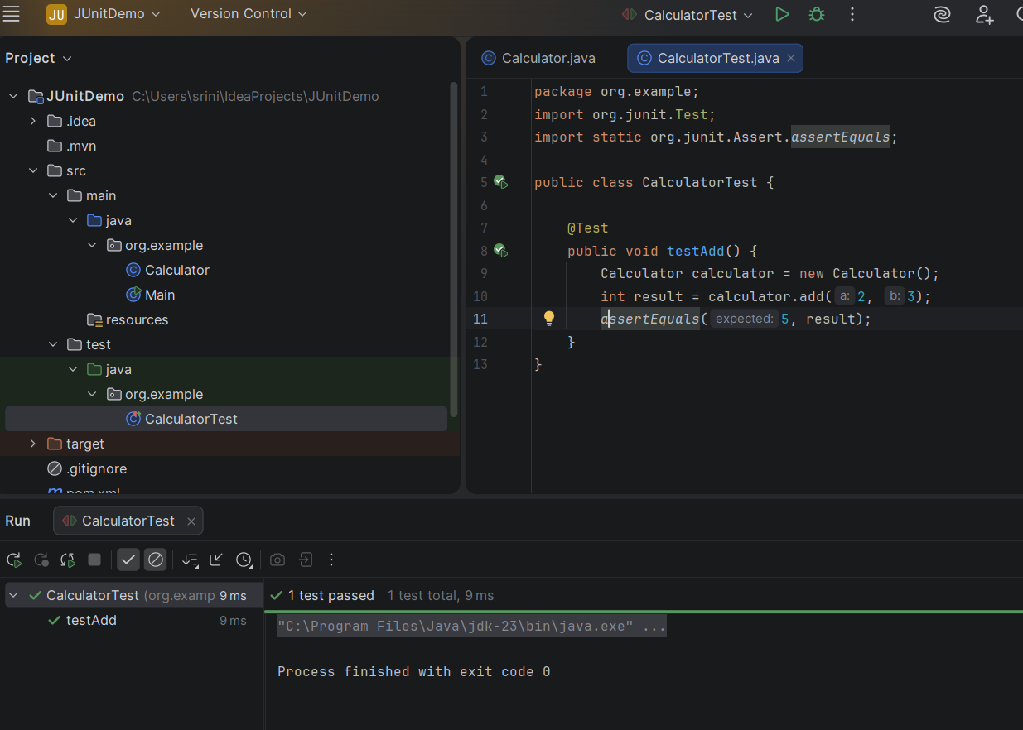
Exercise 3: Assertions in JUnit
Scenario: You need to use different assertions in JUnit to validate your test results. Steps:
- Write tests using various JUnit assertions.
- Solution Code:

import org.junit.Test;
import static org.junit.Assert.*;

public class AssertionsTest {

@Test
public void testAssertions() {
// Assert equals — checks two values are equal
assertEquals(5, 2 + 3);

// Assert true — checks a condition is true
assertTrue(5 > 3);

// Assert false — checks a condition is false
assertFalse(5 < 3);

// Assert null — checks a reference is null
assertNull(null);

// Assert not null — checks a reference is not null
assertNotNull(new Object());
}
}
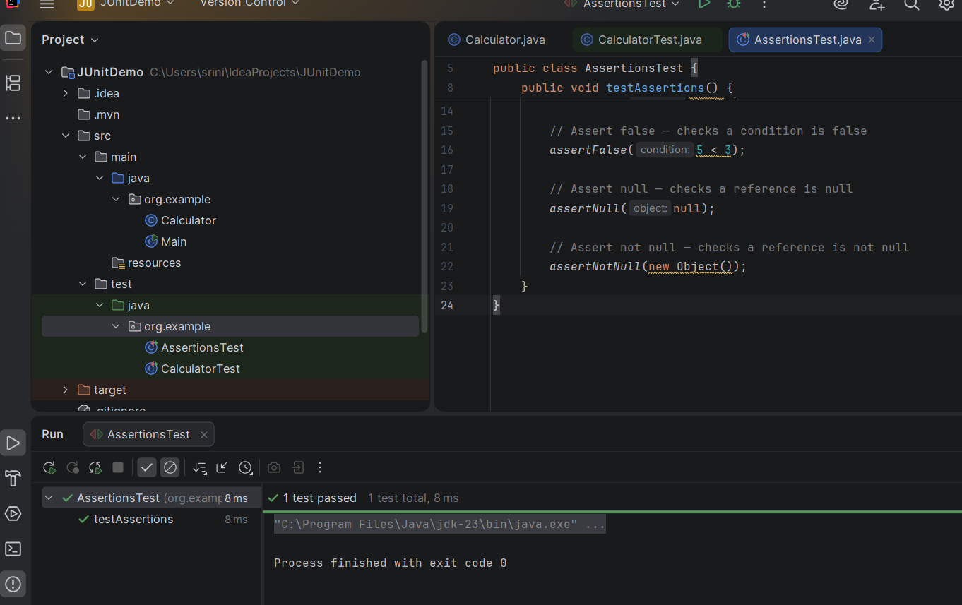

Exercise 4: Arrange-Act-Assert (AAA) Pattern, Test Fixtures, Setup and Teardown Methods in JUnit
Scenario:
You need to organize your tests using the Arrange-Act-Assert (AAA) pattern and use setup and teardown methods.
Steps:
1. Write tests using the AAA pattern.
2. Use @Before and @After annotations for setup and teardown methods.
Code:
package org.example;
import org.junit.Before;
import org.junit.After;
import org.junit.Test;
import static org.junit.Assert.*;
import java.util.ArrayList;
import java.util.List;
public class ShoppingCartTest {
private List<String> cart;
@Before
public void setUp() {
cart = new ArrayList<>();
System.out.println("Setting up: new cart created");
}
@After
public void tearDown() {
cart = null;
System.out.println("Tearing down: cart cleared");
}
@Test
public void testAddItem() {
String item = "Laptop";
cart.add(item);
assertEquals(1, cart.size());
assertTrue(cart.contains("Laptop"));
}
@Test
public void testRemoveItem() {
cart.add("Phone");
cart.add("Headphones");
cart.remove("Phone");
assertEquals(1, cart.size());
assertFalse(cart.contains("Phone"));
assertTrue(cart.contains("Headphones"));
}
@Test
public void testEmptyCartInitially() {
assertTrue(cart.isEmpty());
assertEquals(0, cart.size());
}
}
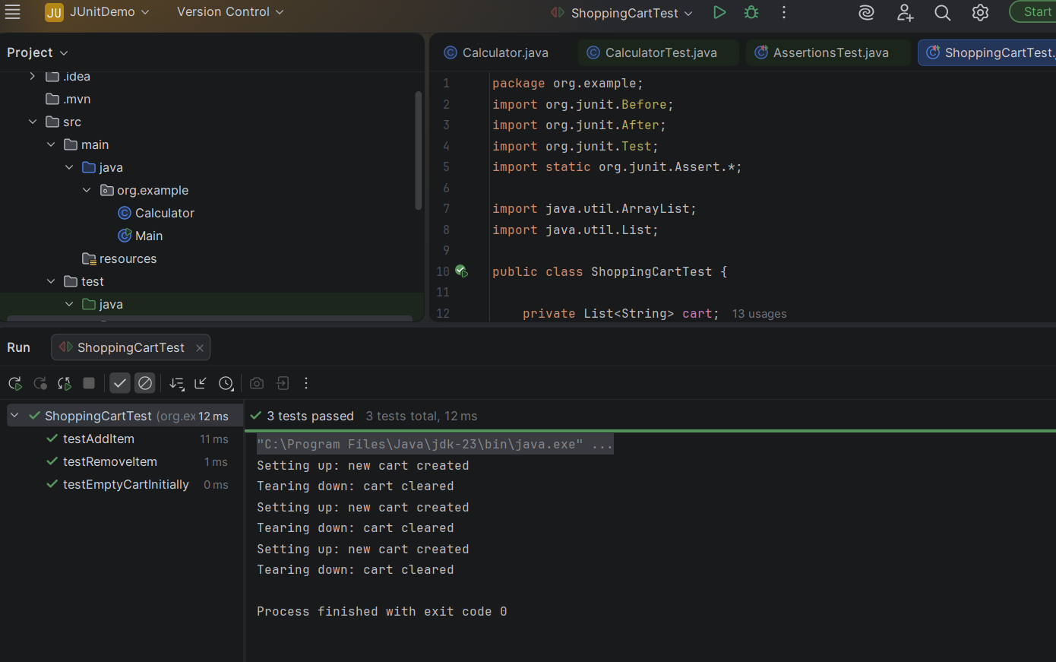

Mockito Hands-On Exercises
Exercise 1:
Mocking and Stubbing Scenario: You need to test a service that depends on an external API. Use Mockito to mock the external API and stub its methods.
Steps:
- Create a mock object for the external API.
- Stub the methods to return predefined values.
- Write a test case that uses the mock object.

ExternalApi.java
package org.example;
public interface ExternalApi {
String getData();
}
MyService.java
package org.example;
public class MyService {
private ExternalApi api;
public MyService(ExternalApi api) {
this.api = api;
}
public String fetchData() {
return api.getData();
}
}
MyServiceTest.java
package org.example;
import org.junit.Test;
import static org.junit.Assert.assertEquals;
import static org.mockito.Mockito.*;
import org.junit.jupiter.api.Test;
import org.mockito.Mockito;
public class MyServiceTest {
@Test public void testExternalApi() {
ExternalApi mockApi = Mockito.mock(ExternalApi.class); when(mockApi.getData()).thenReturn("Mock Data");
MyService service = new MyService(mockApi);
String result = service.fetchData();
assertEquals("Mock Data", result);
}
}

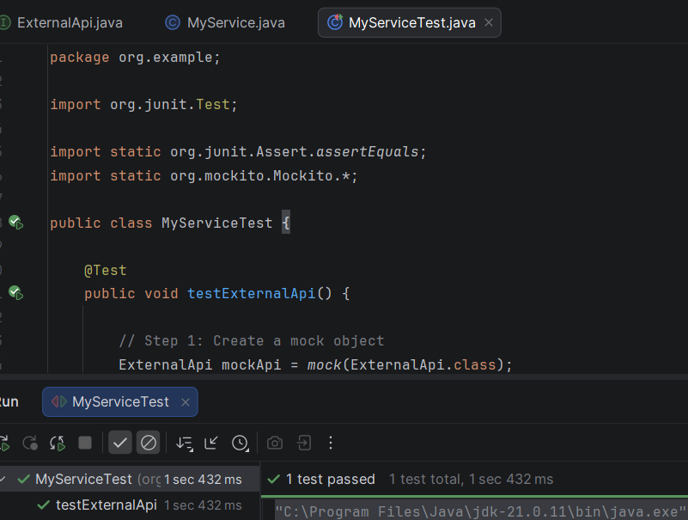
Exercise 2: Verifying Interactions Scenario:
You need to ensure that a method is called with specific arguments.
Steps: 1. Create a mock object. 2. Call the method with specific arguments. 3. Verify the interaction.
MyServiceTest.java
package org.example;
import org.junit.Test;
import static org.mockito.Mockito.*;
public class MyServiceTest {
@Test
public void testVerifyInteraction() {
ExternalApi mockApi = mock(ExternalApi.class);
MyService service = new MyService(mockApi);
service.fetchData();
verify(mockApi).getData();
}
}
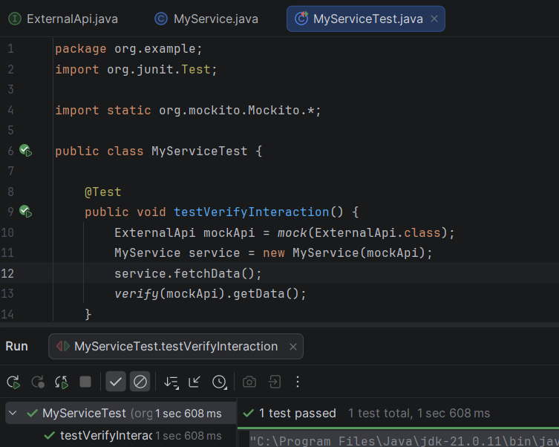
Logging using SLF4J
Exercise 1:
Logging Error Messages and Warning Levels Task:
Write a Java application that demonstrates logging error messages and warning levels using SLF4J.
LoggingExample.java
package org.example;

import org.slf4j.Logger;
import org.slf4j.LoggerFactory;

public class LoggingExample {

// Create a logger object
private static final Logger logger =
LoggerFactory.getLogger(LoggingExample.class);

public static void main(String[] args) {

logger.error("This is an error message");

logger.warn("This is a warning message");
}
}
